Gorgeous Glory (In picture) —Epitome

Palomino like Krista’s Chips model…dapples?--Pendragon

Sunburnt black or DARK dappled bay sabino--Lady Phase

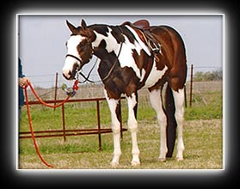 Gorgeous Glory—Epitome

http://www.ironwoodacres.com/frosty.htm Lady Phase (not yet sent)

http://www.aqhabuckskins.com/ maybe with some overo or sabino ☺ Classic QH

Bay/white Tobiano (Gypsy Cob-type) Classic Shire

http://www.gypsyhorses.com/greatimports/scottie.jpg Elfhaime

Lemme know if you've got questions for me :) If in doubt...just do what you think would look cool...I trust ya!
Hilary

